Test Cases for Following Value Inputs

Input Value 15

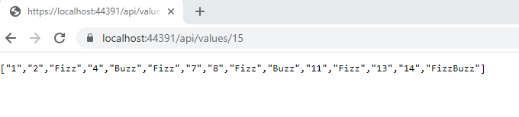

Input Value 2

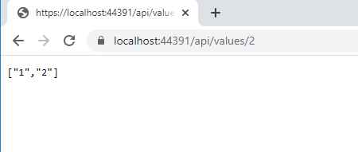

Input Value 25

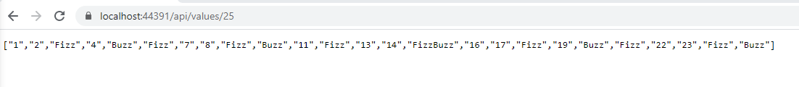

Input Value 100

